Video to download XAMPP:

<https://www.youtube.com/watch?v=-f8N4FEQWyY>

Once XAMPP is installed, launch it and click start for Apache and MySQL.

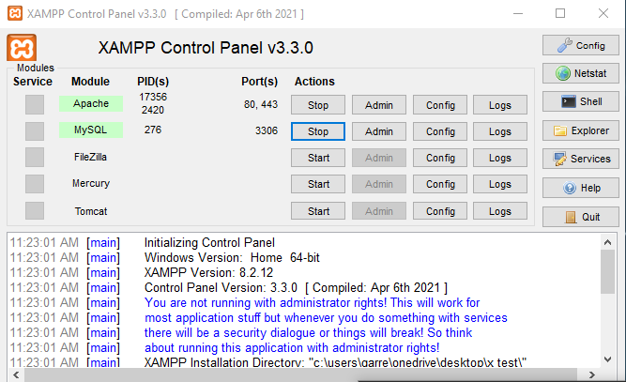

After that, go here: <http://localhost/phpmyadmin/>

Once on the page, click new in the left hand corner of the screen and type in register. 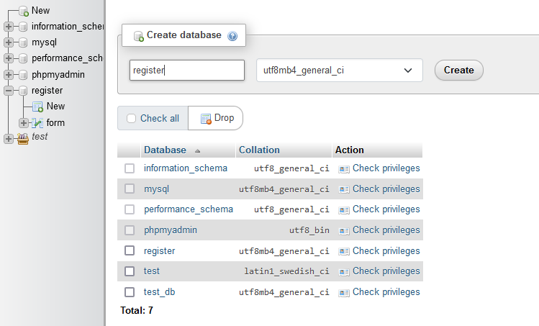

Then, type in form and then 3 number columns.

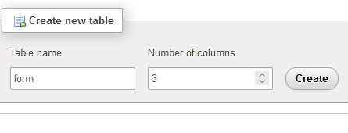

Write this info in and save lastly.:

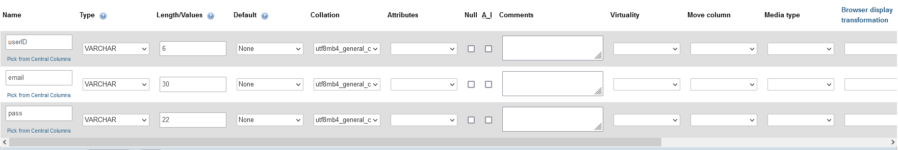

Once done, click on Structure, selected userID, and then click primary.

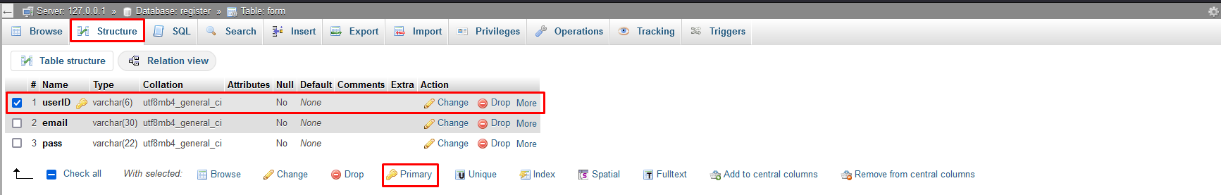

Lastly, wherever you saved the xampp folder, open it and go to htdocs and copy the folder from github and past it in

